1. I’m quite good ___ English.
in
at
on
with

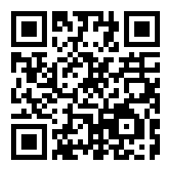

2. Smoking is bad ___ you.
with
without
for
at

3. I’m perfectly capable ___ doing it myself.
on
at
of
in

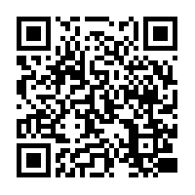

4. She’s married ___ a doctor.
to
with
at
without

5. The book is written ___ Rowling.
from
of
on
by

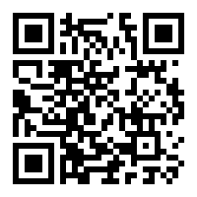

QR CODES Prepositions Solution

1. I’m quite good ___ English.
in
at
on
with

2. Smoking is bad ___ you.
with
without
for
at

3. I’m perfectly capable ___ doing it myself.
on
at
of
in

4. She’s married ___ a doctor.
to
with
at
without

5. The book is written ___ Rowling.
from
of
on
by

